To: ALL RESIDENTS & STAFF
From: ANDREW DUJON, President/Chief Executive Officer
RE: Recent Survey Results
Date: June 23, 2025

Good morning,
I hope this finds you doing well. Below are the results of our recent surveys:
Lodge Buffet Menu Preference Survey – 253 responses
- Do you enjoy the Lodge Buffet having a separate lunch and dinner menu, or do you prefer one menu served all day?
  - 48.2% of people said they prefer the same meals offered at lunch and dinner, 23.7% had no preference, and 28.1% enjoy having different options for lunch and dinner.
Lodge Café & Culinary Experience Survey – 142 responses
- Would you like to see breakfast brought back to the café?
  - 60% of residents said they were indifferent.
- Would you prefer a salad bar over pre-made items?
  - 63% of people said yes.
- Would you prefer to see more daily or weekly specials in the café?
  - 59% of people said yes.
- Is the overall Culinary experience in the Lodge working so far?
  - 56% of people said they were satisfied.
Culinary Feedback – Lodge/Café – 174 responses
- Are you satisfied with the current offerings in the Lodge?
  - 59% of people said they were satisfied.
- Are you happy to see the salad bar back?
  - 81% of people said yes.
- Do you enjoy having breakfast back in the Café?
  - 31% said yes, and 66% said not applicable.
- How is the service in the Lodge?
  - 93% said it meets or exceeds expectations.
Socialization Survey – 198 responses
- Since the closure of the Lodge's main dining venue, how often do you eat meals with other residents?
  - 37.4% said a few times a week, 10.6% said daily, 17.7% said once a week, 16.7% said less than once a week, and 17.7% said not at all.
- How has the closure of the Lodge's main dining venue affected your ability to socialize with other residents during meals?
  - 44.9% said there was no change, 32.3% reported that it somewhat reduced socialization, and 19.2% stated that it greatly reduced socialization.
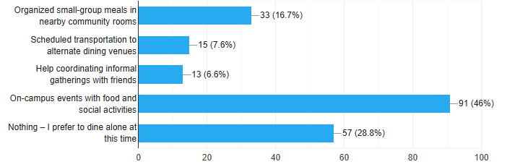
- What would make you more likely to socialize with other residents during this renovation period? (Select one)

- If small-group meals were offered in alternate spaces (e.g., lounges, patios), how likely would you be to attend at least once a week?
  - 43% said they were unsure, 31% said they were likely, and 26% said they were unlikely.
- Which factor is most preventing you from socializing during meals right now?
  - 28% said there is no convenient communal dining space, 27% stated a personal preference for eating alone, 26% reported not knowing who else would be participating, and 14% cited a lack of awareness about available options.

