Senior Health & Fitness Day!

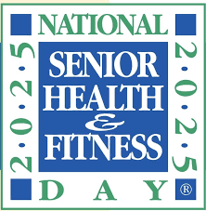

May 28th 2025

8:30 AM- 11:30 AM

* Dietician talk Chapel 9:00-9:45

(Stroke prevention & Bone Heath with Diet

* Games with Home Health & Outpatient therapy Lakeside Grande
* Hula Hoop
* Tailgate Toss
* Seated Chair Dance 11:00-11:30 Lakeside Essence room



**Contact the Wellness with any question Ext 304 & 509**