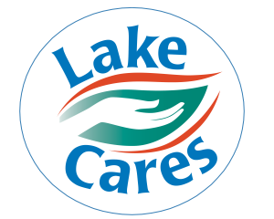

lake cares food drive

# Feeding the Body, Educating the Mind and Lifting the Spirit of All Individuals.

STARTING JULY 1ST - 14

TWO WHOLE WEEKS!!

**CASH DONATIONS CAN BE BROUGHT TO THE WELLNESS CENTER**

**$16 A WEEK FEEDS 1 CHILD $160.00 FEEDS 1 CHILD THE WHOLE SUMMER**

DROP OFF BOX WILL BE PLACED AT 3 RECEPTIONIST DESKS

LAKESIDE, OAKSIDE AND BRIDGEWATER.

SPECIFIC ITEMS REQUESTED FROM LAKE CARES ARE:

**#1 CANNED FRUIT & MEATS AND BOXES OF CEREAL.**

**OTHER REQUESTED ITEMS**: Dry Cereal, Canned Meats/Tuna, Salmon and Chicken, Dry or Canned Beans, Pasta and Sauce, Rice, Peanut Butter/Jam/Jelly, Canned Vegetables, Canned Fruit, Soups canned or dried – all varieties of Shelf stable Milks including Baby Food

**PERSONAL ITEMS:** Diapers – All sizes for both Baby & Adults, Deodorant, Shampoo and Conditioner, Toothpaste, Mouthwash, Toothbrushes, Dental Floss, Soap, Body wash, Laundry/Dish soap.

To ensure we are providing safe and high-quality food to our community, please **check expiration dates** before donating. We kindly ask that all items be within their expiration date to help us maintain a safe and reliable food supply.

 https://azstorage.reliaslearning.com/authsa/logos/8807/636990492058033593.jpgSponsored by the WELLNESS COMMITTEE