
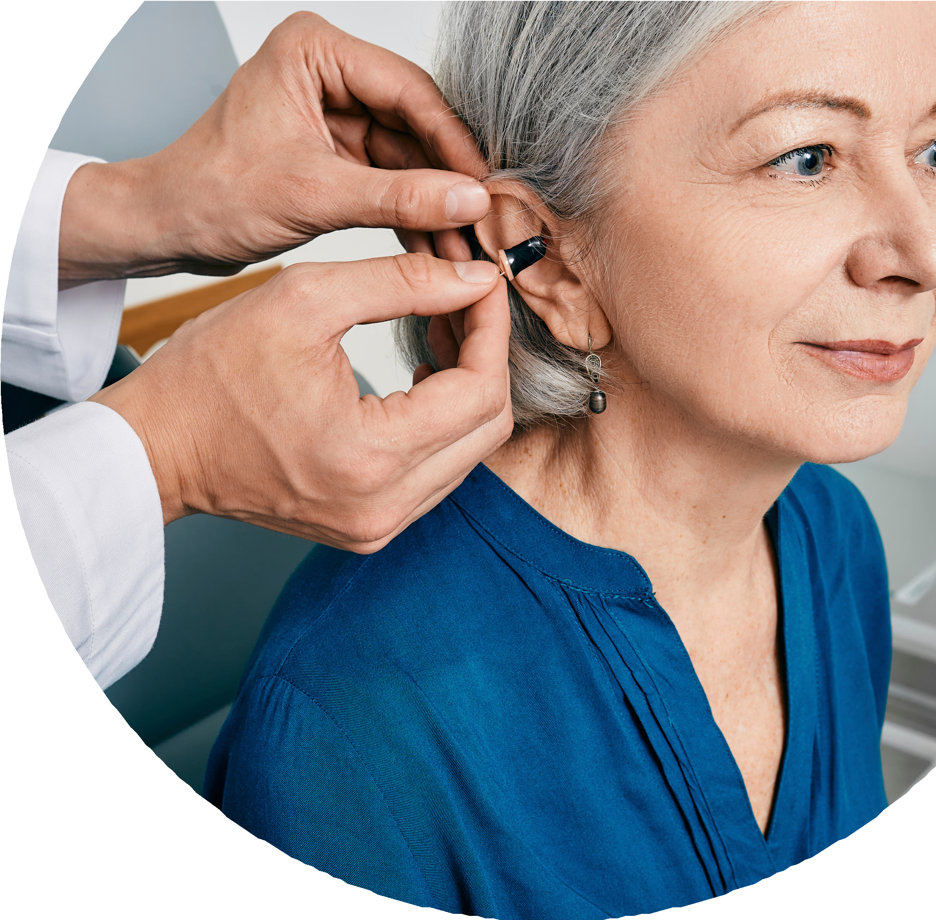

September 9th at 2pm in the Chapel

Dr. Danielle Rosier, Audiologist

Audiology Expert
Rosier Audiology, LLC provides the following mobile services:



Hearing Exams
Join our Visually Impaired Person’s monthly
meeting to see how hearing loss ties to low vision !


Hearing aid fittings/repairs Speech in noise testing Wax Removal

Tinnitus Evaluations Aural Rehabilitation

For more information please reach out to Dan Doupe or Kendra Criss VIP stands for Visually Impaired Persons.

