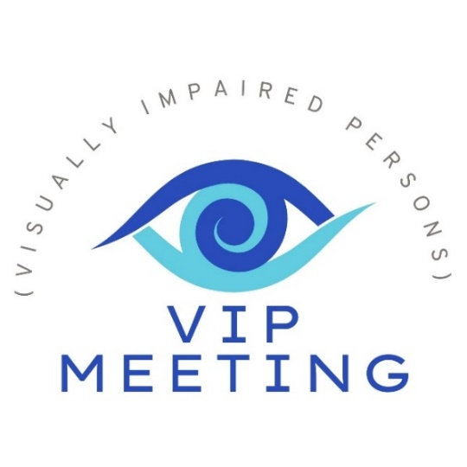
Speaker:
Annika Kretschmer
Assistive Tech Specialist

Title: Low Vision Device Showcase

Annika Kretschmer, MSW, an assistive technology specialist, will be showcasing low vision devices such as Vision Buddy Mini, eSight Go, MirrorPad Pro, LyriQ, Metaglasses and more. These tools can greatly increase your independence with magnification, high contrast colors and more. Read your mail, see pictures of the grandkids, and watch your favorite TV Shows. Annika will demonstrate the devices, and then provide time for everyone to ask questions and get their hands on the devices. Check out the website: Www.Floridareading.com
All are welcome! Share with your neighbors!
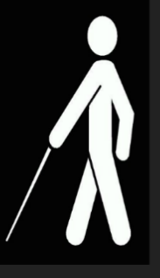

Where: CHAPEL
When: January 13, 2 PM
Check in starts at 1:30
VIP is a support group of VISUALLY IMPAIRED PERSONS who meet monthly to get information and help to improve their daily living to the greatest possible extent.
Questions? Call Kendra x301 or Dan Doupe (585-451-3935)

