**\*HOME AND COMMUNITY BASED SERVICES – Contact List\***

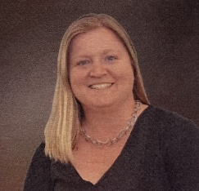**Kendra Criss, Executive Director of Home and Community Based Services**

*\*Contact for general questions on services when you don’t know who to contact or*

*what services are needed. Concerns or complaints regarding Waterman Villages*

*Home Care or Outpatient Therapy departments.*

[kcriss@watermanvillage.com](mailto:kcriss@watermanvillage.com) (352) 383-0051 x301

**Maggie Walsh, Clinical Liaison**

*\*Contact when have a physical decline, when in hospital, when discharging from*

*hospital or skilled rehab. If have an upcoming procedure.*

[mwalsh@watermanvillage.com](mailto:mwalsh@watermanvillage.com) Mobile: (407) 782-8092

**Rosa Lesperance, Resident Relations** **Resident Relation Team – Ubi and Mariana**

\**Contact for questions or concerns regarding services on campus or assistance*

*on who you should contact for specific questions.*

*Looking for suggestions on local doctors, Home health or outpatient.*

[rlesperance@watermanvillage.com](mailto:rlesperance@watermanvillage.com) (352) 383-0051 x 294

**Jennifer Gibson, Home Health Administrator**

*\*Contact for concerns or questions related to Home Health or Private duty specific.*

[hhadministrator@watermanvillage.com](mailto:hhadministrator@watermanvillage.com) (352) 383-0051 x 271

Intake Coordinator, Karen (352) 383-0051 x 231

*\*Contact when have order for Home care or questions on how to get orders from your doctor. As well as nursing or therapy scheduling.*

Private Duty scheduler, Octavia (352) 383-0051 x 381

*\*Contact when looking for private duty services in your home*

**Juliana Wright, Outpatient Manager**

*\*Contact for concerns or questions related to Outpatient Therapy specific.*

[outpatienttherapy@watermanvillage.com](mailto:outpatienttherapy@watermanvillage.com) (352) 383-0051 x 303

**Michelle Carroll, Wellness Director**

*\*Contact to schedule private session or for a wellness screen. Ask about classes*

*or how to use specific machines in wellness gyms.*

[wellness@watermanvillage.com](mailto:wellness@watermanvillage.com) (352) 383-0051 x 304

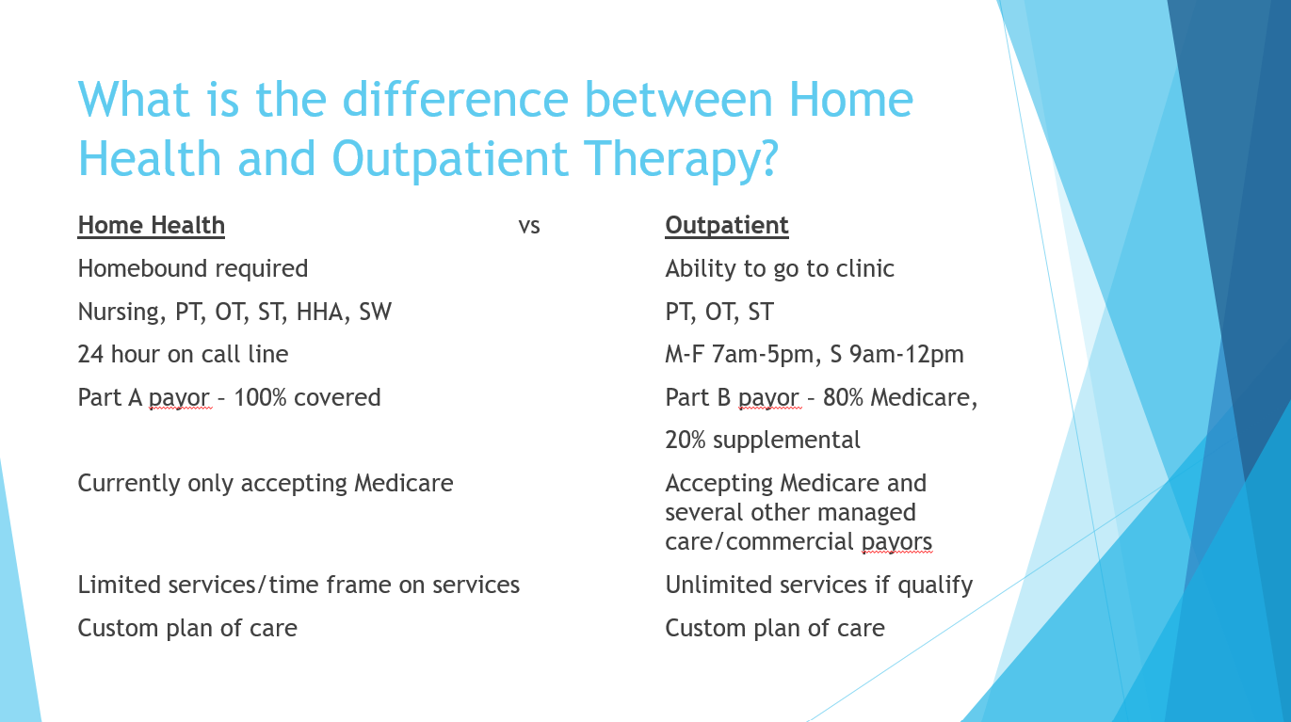

**How do I know what services I need?**

*We recommend utilizing your full benefit and starting with Home Care. This is where they will work with you in your home and make sure you are safe and able to do all needed things in your home environment. They can make home safety recommendations, practice doing real tasks that are difficulty for you in your home and get you to you highest potential in your home.

*If you are in the hospital for whatever reason, we recommend having home care come out, even if just a short time to prevent re-hospitalization and assist getting you back to your prior level of care. After home health discharges we will seamlessly shift services to outpatient where you can continue to progress.

*If you have a planned surgery or procedure coming up we recommend home care or outpatient therapy to get you ready and stronger. This is make your recovery much easier and shorter if you do “pre-hab therapy”. Ask your doctor for orders for home care if “homebound” and outpatient if not.

*If you are unaware where to start, start with home care it is shorter services, works at home with you and gets you ready for Outpatient. Then move on to Outpatient Services.

*You have patient choice on what doctor you go to, which hospital you choose, Skilled rehab, Home Care, and Outpatient you prefer.

*DISCLAIMER – You cannot be on Home health and Outpatient services at the same time.