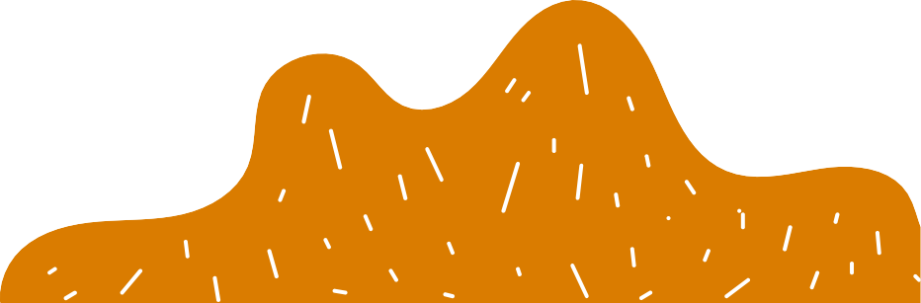



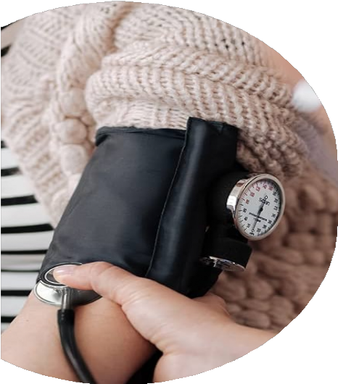
WELLNESS CLINIC
#1
Join us for a quick wellness update. Status will be saved each quarter to compare and see progress/decline. You will also receive data to compare with others in your age bracket. If you attend 2 of the 2 clinics you will get a REWARD!

February 26th
9am-11am Lakeside Essence Room 1pm-3pm Oaks Wellness Room
Sign up in the activity binders on each
side of campus.
C L I N I C T O I N C L U D E :
Overall Strength
Blood pressure/weight Fine Motor Coordination Balance/Coordination Swallowing/cognition
Event hosted by Home and Community Services -
Collaboration with Wellness, Outpatient Therapy and
Home Health Services

