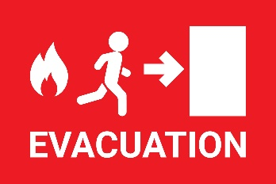

**Independent Living / High Rise Building Fire Evacuation Procedure**

In the event of a fire, immediate evacuation is crucial if physically able. The standard procedure involves alerting others, activating the fire alarm, and using the nearest exit to the designated assembly point. Do not use elevators and, if possible, close doors behind you to slow the spread of fire. If unable to evacuate stay in place.

**1. Alert and Activate:**

If you discover a fire, immediately alert others and activate the nearest fire alarm or pull station.

**2. Evacuate:**

Follow EXIT signs to the nearest safe exit, which is typically a stairwell. Avoid elevators.

**3. Close Doors:**

As you evacuate, close doors behind you if possible to help confine the fire and smoke.

**4. Move to Designated Assembly Point:**

Report to the designated assembly point outside the building, away from the fire and First Responders will take over further direction.

**5. Account for Everyone:**

Check to see if anyone needs assistance and notify First Responders.

**6. Do Not Re-enter:**

Do not re-enter the building without official clearance from First Responders.

Additional Tips for Safe Evacuation:

* **Stay Calm:** Remain calm and follow instructions from emergency personnel.
* **Check Doors:** If you have to open a door, test it for heat before opening it.
* **Stay Low:** If there is smoke, stay low to avoid inhaling fumes.
* **Listen for Instructions:** Listen for instructions from emergency personnel or fire department.
* **Know Your Routes:** Familiarize yourself with escape routes and assembly points in your building.
* **Practice:** Regularly participate in fire drills to practice the evacuation procedure.