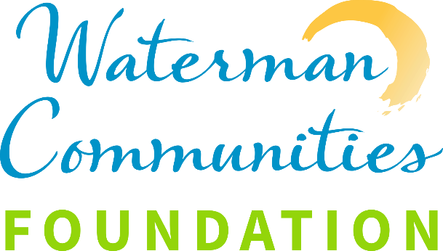

DONATION AUTHORIZATION FORM

TO THE WATERMAN VILLAGE FOUNDATION

Resident Name: Phone:

Address:

I give my permission and authorization to add the following amount to my monthly bill. I understand that I may discontinue or alter this donation plan at any time. Alternatively, I also have the option to make a one-time donation, which will not affect my future billing.

Monthly donation of $ for the Waterman Village Foundation.

Quarterly donation of $ for the Waterman Village Foundation.

Annually donation of $ for the Waterman Village Foundation.

One time donation of $ ______ for the Waterman Village Foundation.

Resident Signature:

Date:

*** Place the signed form in the Rent Box in the Lodge or Lakeside for collection ***

Rev. 06/26/25 ES