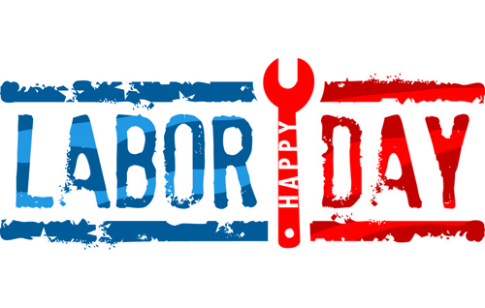



To: All Residents planning to celebrate Labor Day in

The Lodge & Savor

Oaks Lodge: To provide a quality holiday meal service and to allow our employees an opportunity to enjoy a part of the holiday with their families, Culinary Services will be offering limited service hours on Monday, September 1st, in The Card Room.
The hours for the Card Room will be 11 AM - 3:00 PM
Promptly close at 3:00 PM
Take Out / Pick Up Order
383-0051, ext. 258
Meal Delivery Times: 11 AM and 2 PM
No evening delivery service will be available

Lakeside Savor: Culinary Services will be offering limited service hours on Monday, September 1st.
The hours for the dining room will be 11 AM - 2:00 PM
Promptly close at 3:00 PM
Each seating will be first-come, first-served basis.
Take Out / Pick Up Order
383-0051, ext. 500
Meal Delivery Times: 11 AM and 2 PM
No evening service will be available

Waterman Café, Lakeside Brew Bar, & Sports Bar will be closed.
Residents & guests can wear casual luncheon attire.

