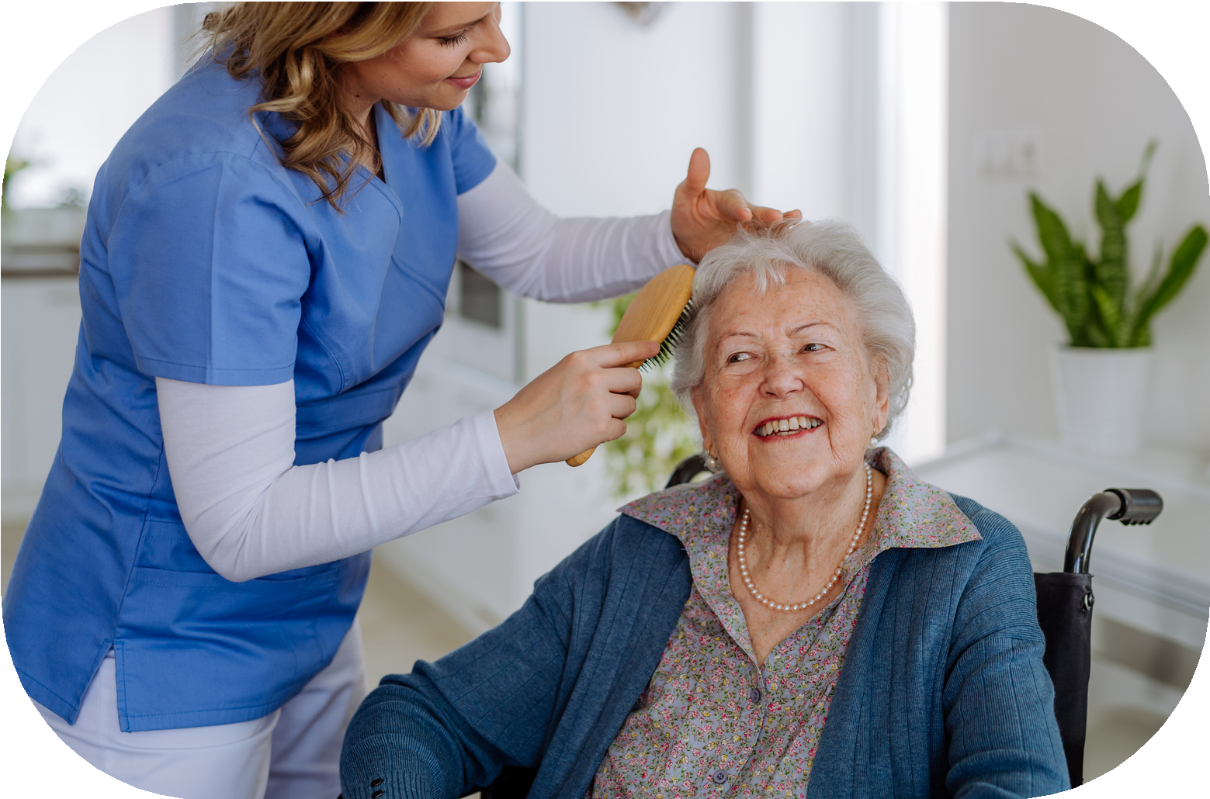
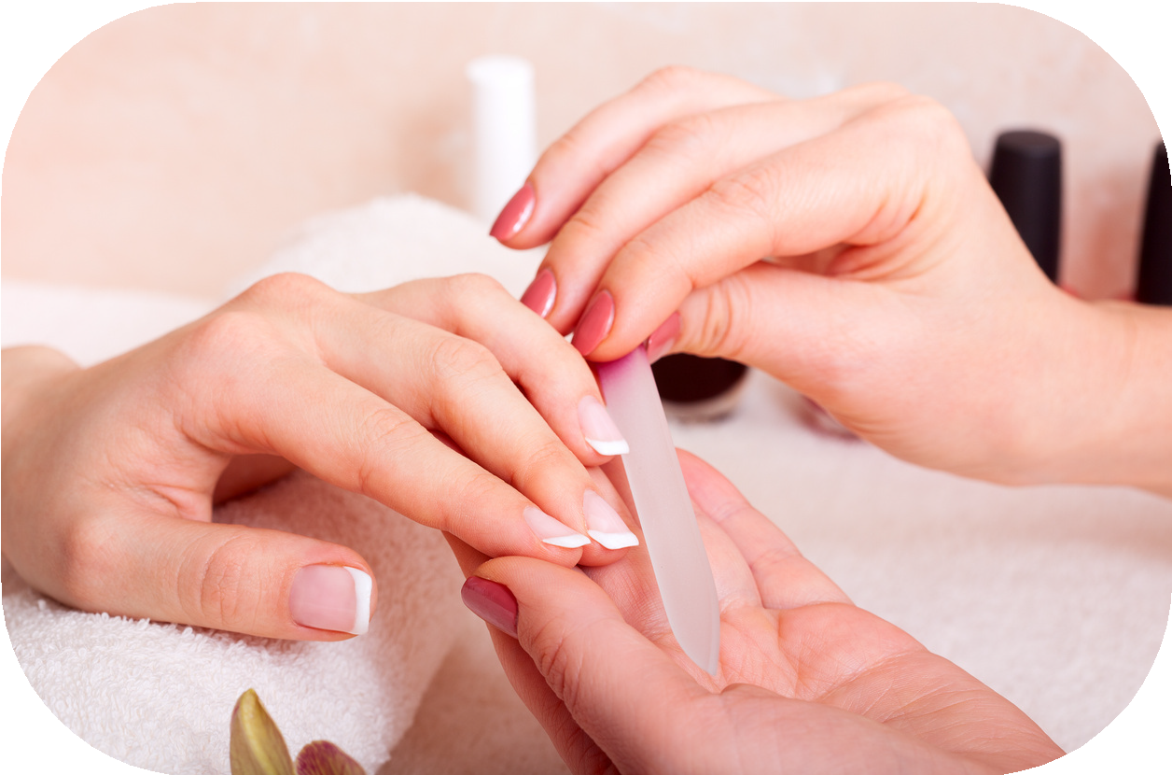
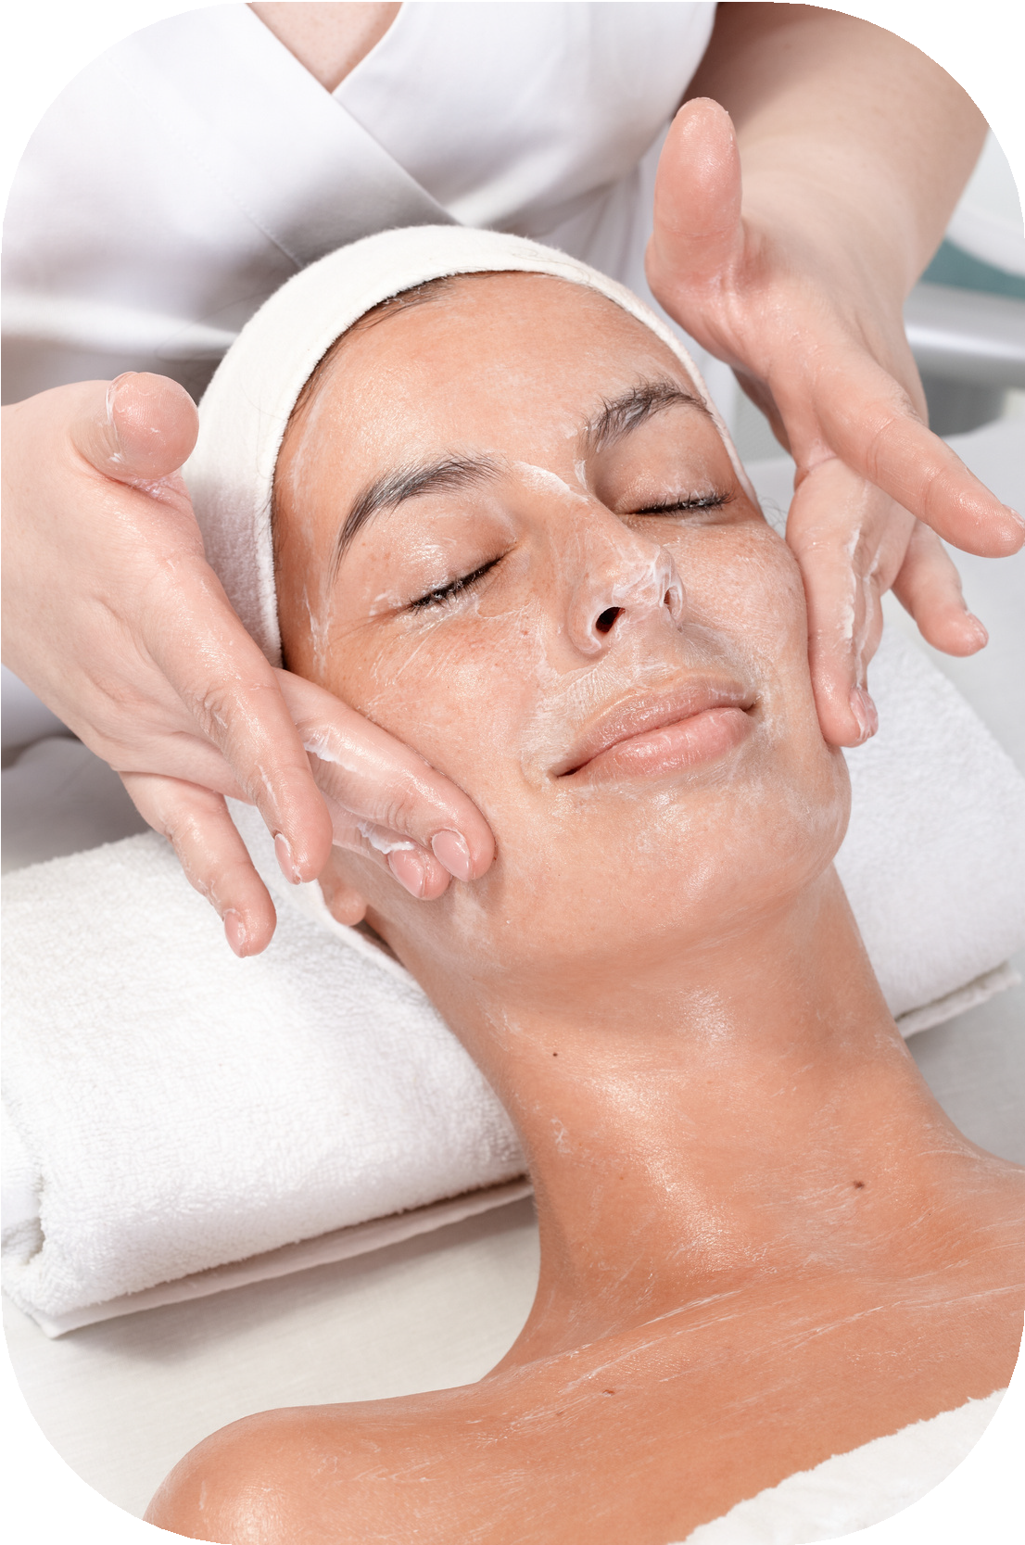
LAURA’S BEAUTY SALON

Services
*PLEASE NOTE: THIS IS TEMPORARY.

Hair
Oaks - Call Laura at ext 286 Shampoo/Set $25 Rinse $2 Shampoo/blow $25 Frost $65
Ladies Haircut $25 Mens haircut $20 Color $55 Shampoo only $6 Perm $75

Nails - Fingers and Toes
Lakeside - Call Victoria at (561) 859-1103
Manicure $25 Toenail Clip $17
Pedicure $35 Fingernail Clip $17 Deluxe Pedicure $45 Dip Powder $45 French add on $10 Gel add on $10

Facials
Lakeside - Call Ella at (314) 616-2544
Classic Facial $50 Add ons:($10 each) Extraction Facial $75 LED light therapy Sensitive Skin Facial $70 Dermaplanning
Scalp Massage Lymphatic Drainage Massage

MASSAGE ENVY

Massage Services

Massage
*PLEASE NOTE: THIS IS TEMPORARY.

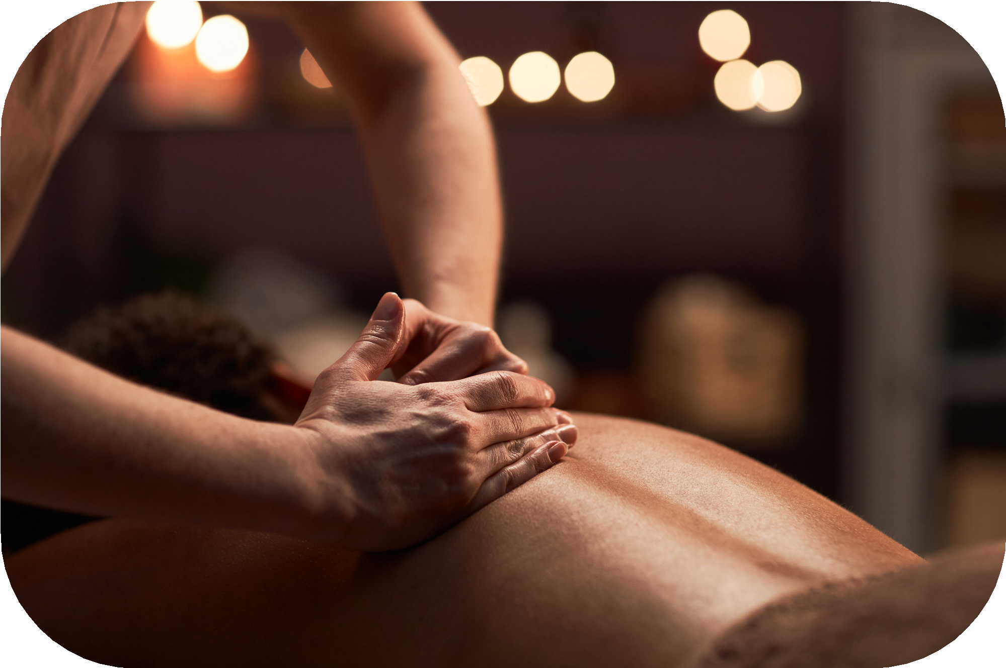
With Membership and card on file: First Massage of each month $70 Each additional Massage $65 OR: $75 each massage with no membership
- Call Massage Envy at (689)262-6266 to book an appointment.
- Waterman Village can transport you there if needed. Call Transportation to set up ext 222.
- Info on the monthly subscription. You sign up and give them your credit card. They will charge you monthly. If you do not use the monthly massage it will roll over to the following month.
- If you do not want to be a member, you still put a card on file, however you are only charged if you get a massage.

